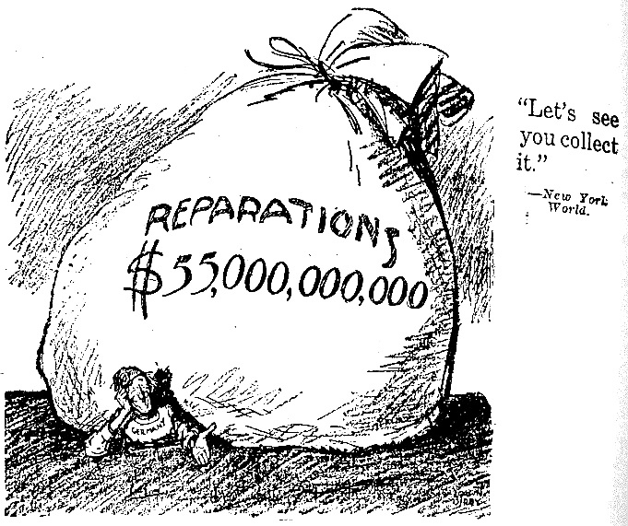
An American cartoon commenting on the Treaty of Versailles from 1920.

- What are reparations? Why is the bag so large?
- Who is underneath the bag, what is happening to them?
- Why might an AMERICAN make this cartoon? What did they think about the T of V?

